**Web Development: Dynamically Generated Content**

**2. HTML, CSS and PHP Refresher Exercise**

Create a new website in HTDOCS called **perfecto**

Use the wireframes as a guide to create 3 webpages – ***index.php, login.php* and *register.php.***

(*Remember, create one page, use the PHP include command for the header and footer, then save out the page twice and change the main content areas to suit the web page requirements)*

The site will be used for demonstrations and tutorials for PHP and MySQL.

* The company is called Perfecto Sculptures and the logo has been provided.
* Use placeholder images for the banner photo and the photos on the home page. Place holder text can be used for the featured artist.
* Remember – [pixlr](http://www.pexels.com) X is good for free high quality photos
* Emmet lorem command for placeholder text



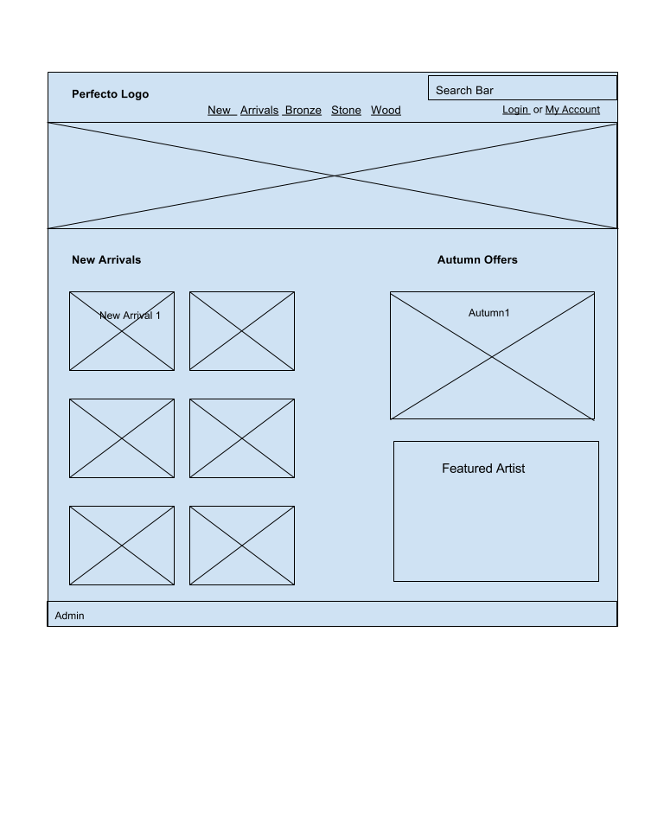The home page:

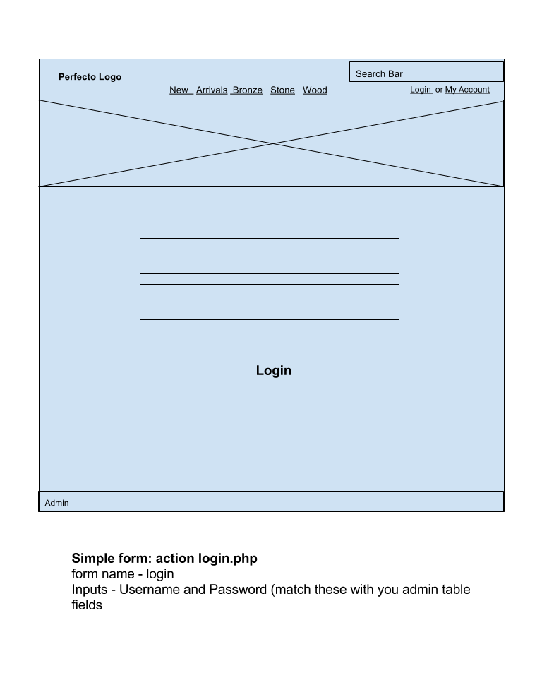The login page:

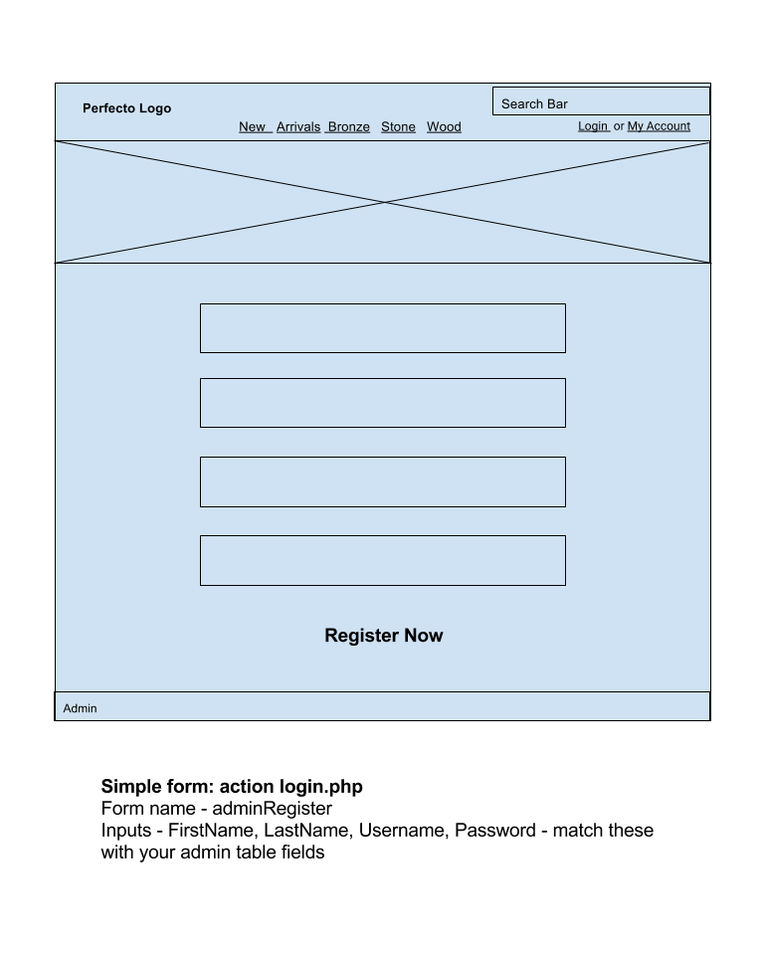The register page: